1. select ename,sal,deptno from emp where deptno in(20,30,40);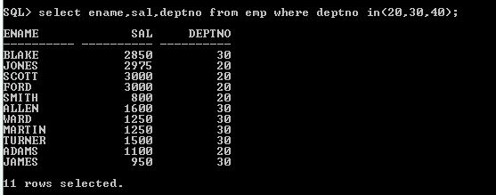
2. select empno as eno,ename as empname,sal as salary,comm as commision,deptno as depnum from emp;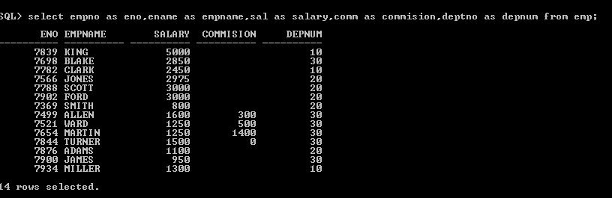
3. select studcode,sub1,sub2,sub3,sub1+sub2+sub3 as total_marks from studmarks;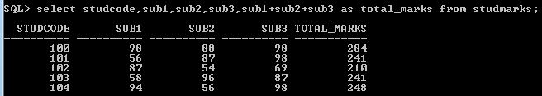
4. select * from staffmasters where designcode= any(select designcode from designmasters where designname = 'proffesor' or designname='lecturer');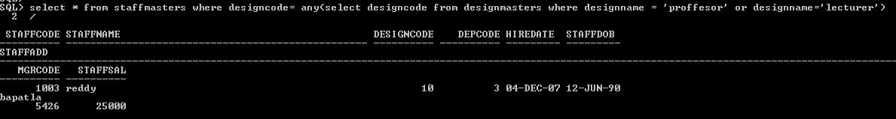
5. select empno,ename,deptno from emp where months_between(sysdate,hiredate)/12 > 18;( OR) select empno,ename,deptno from emp where (sysdate-hiredate)/365 > 18;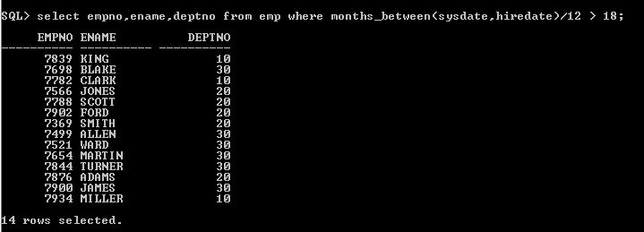
6. select staffname,designname from staffmasters,designmasters where staffmasters.designcode=designmasters.designcode and staffmasters.hiredate < '01-jan-2003'
7. select ename,job,sal*10 as salary from emp where deptno in (10,30);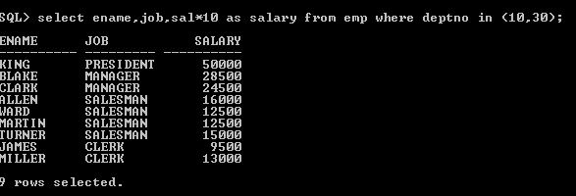
8. select staffname,months_between(sysdate,hiredate)/12 as experience from staffmasters where designcode=any(select designcode from designmasters where designname = 'lecturer');